1)

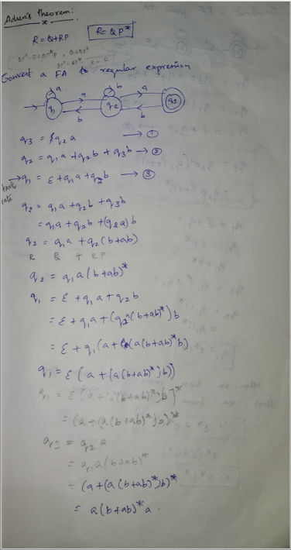

2)

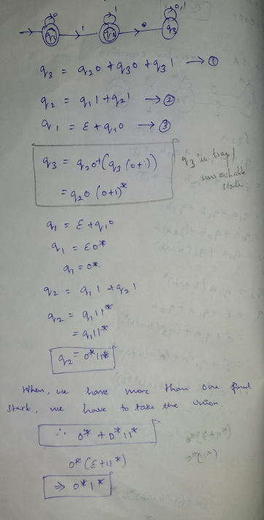

Conversion of Regular expression to finite automata

1) 0*10* L={w|w contains a single 1}   
2) (0|1)* 1 (0|1)* L = {w|w contains at-least a single 1}  
3) (01) U (10)   
4) (0|1 0|1 0|1)*  
5) 0(0|1)*0 + 1(0|1)*1 + 0 + 1

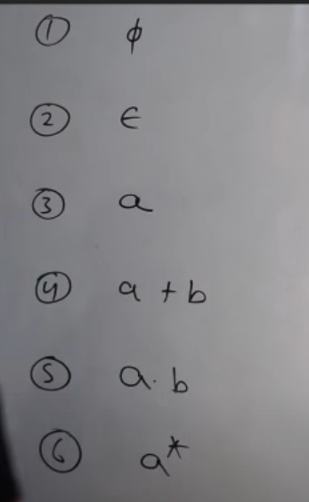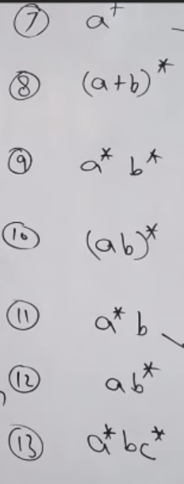

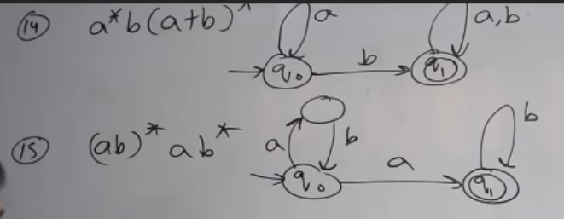

16) (a+ba)*ba

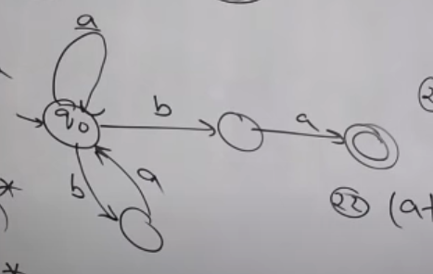



17) (aa+aaa)*



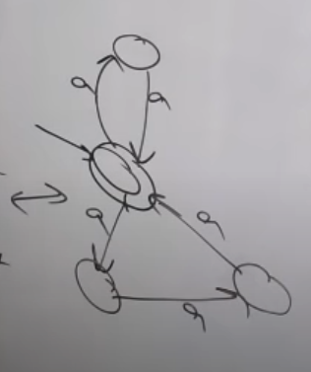(or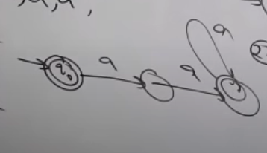



18) (a+aaaa)*

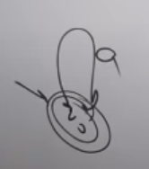

19) (ab)* + (a+ab)*b*(a+b)*

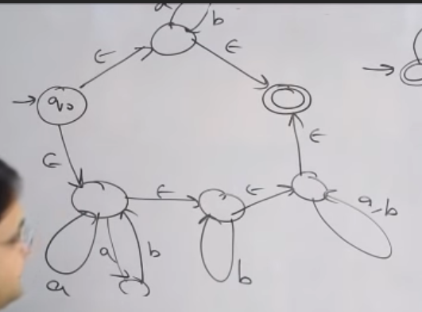 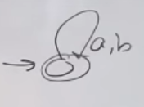



20) [a+ba(a+b)]* a(ba)* b*

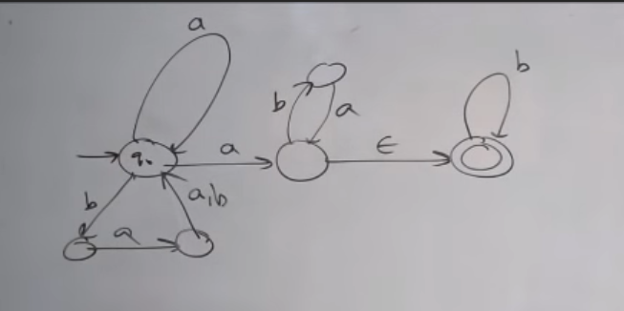

21) b(a+ba+abb) (ba(a+b)*)

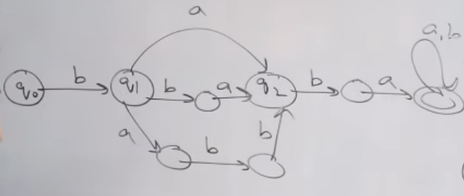

22) (ab U a)*

23) (a U b)* aba

24) (a+b+ca)[ (bab)* + (a+b)* ]* (ab)*

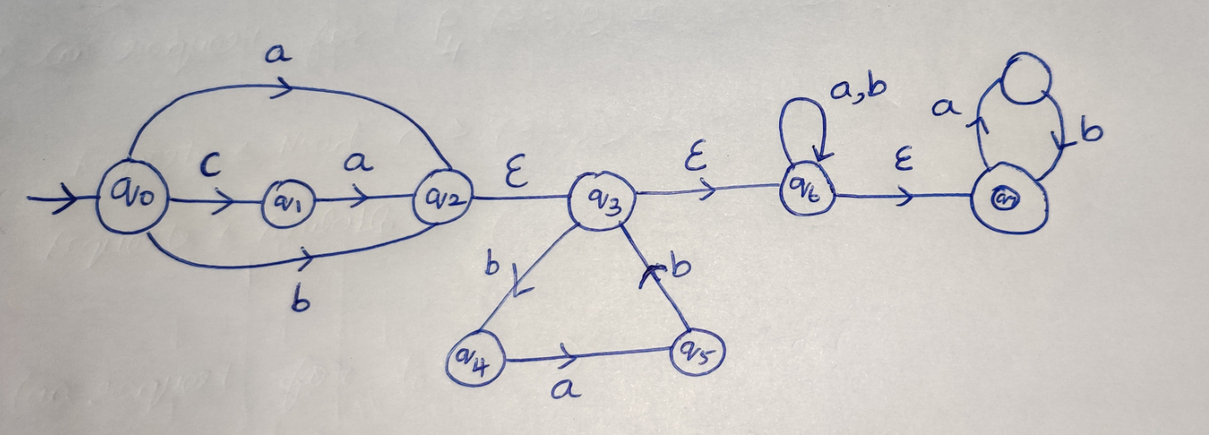

If the input alphabet is then the regular expression   
 🡪 describes the language consisting of all strings of length 1 over this alphabets

* 🡪 describes the language that contains all strings

* 1 🡪 describes the language that contains all the strings ending with 1

**Adren’s theorem**

1)

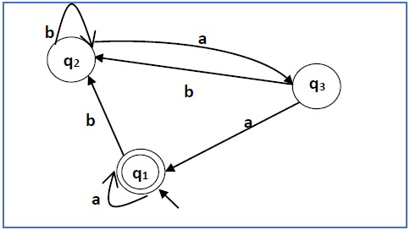

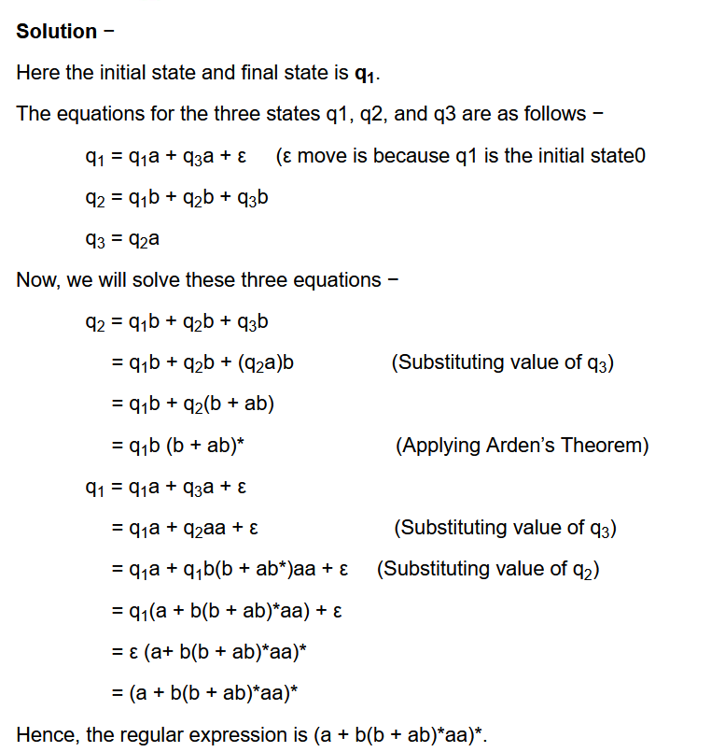

2)

